**Step for install package**

1. Download the ProjectCCA_0.0.0.9000.tar.gz file
2. In R studio, go to “Packages” -> click “Install” -> it will open a window -> select parameter and load the gz file -> click install

screenshot below:

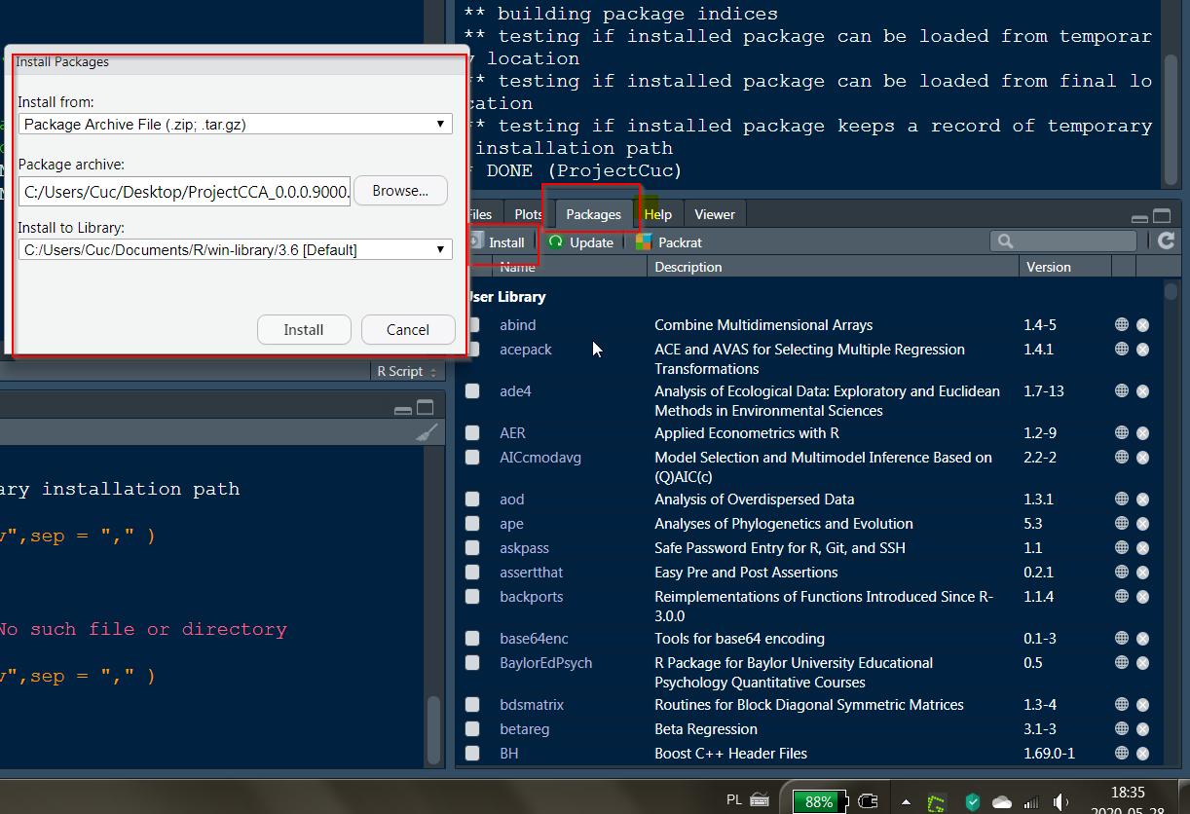

1. Testing package with the codes (you can also test by your chosen parameter from our dataset): I use dt2 – the dataset after cleaning process provided by Catherine to test

ProjectCCA::AVG_Expenditure(dt2, "CAR")

ProjectCCA::AVG_Income(dt2, "CAR")

ProjectCCA::Reg_Expenditure(dt2, "CAR")

ProjectCCA::ExpenditurePlot(dt2, "Household.Head.Sex" )

ProjectCCA::ExpenditurePlot(dt2, "Total.Household.Income")

ProjectCCA::my_reg(Housing.and.water.Expenditure ~ Number.of.Refrigerator.Freezer + Number.of.Airconditioner + Number.of.Landline.wireless.telephones +

Number.of.Personal.Computer + Number.of.Television + Number.of.Washing.Machine + House.Floor.Area, dt2 )